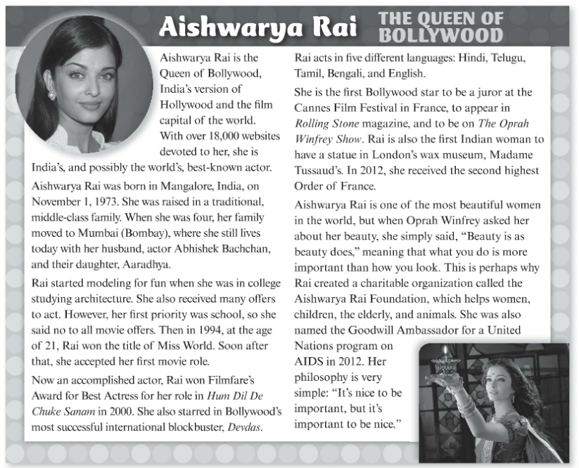

**VOCABULARY**

1. Famous
2. Talented
3. Accomplished
4. Influential
5. Down-to-earth
6. Beautiful
7. Generous
8. Nice

**DISCUSSION**

* What would you do if you get lost?
* Has something similar happened to you or any of your relatives?
* Do you know how to survive if something similar happens to you?