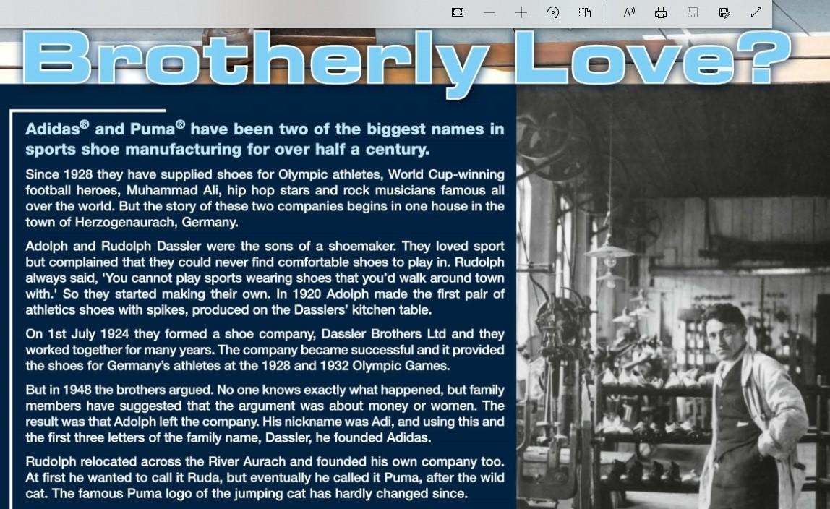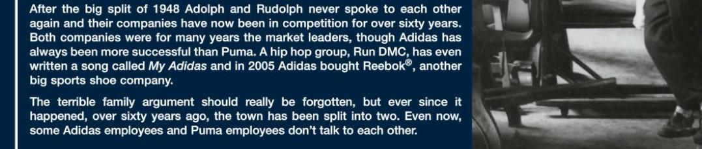

**VOCABULARY**

1. Hope
2. Dream
3. Prize
4. Experience

**DISCUSSION**

* Have you ever had a family business?
* How has the relationship been between all of you?
* What’s your opinion on the Dassler brothers?