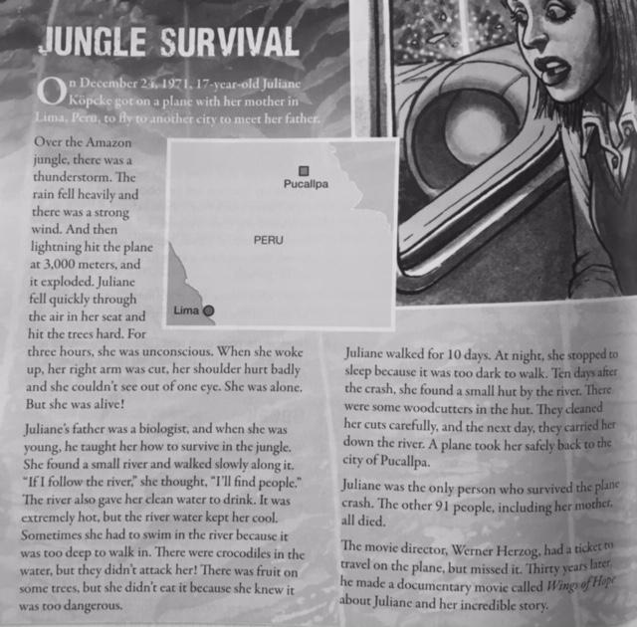

**VOCABULARY**

1. Thunderstorm
2. Survive
3. Unconscious
4. Dangerous
5. Heavily
6. Slowly
7. Carefully
8. Badly

**DISCUSSION**

* What would you do if you get lost?
* Has something similar happened to you or any of your relatives?
* Do you know how to survive if something similar happens to you?